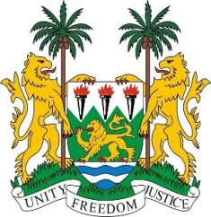
SIERRA LEONE
22nd Session of the UPR

JAMAICA

Statement by Ambassador Yvette Stevens

13 May 2015

Mr President,

Sierra Leone welcomes the delegation of the Jamaica and thanks them for their update.

My delegation notes with appreciation the consistent commitment demonstrated by the Government of Jamaica towards the promotion and protection of human rights, as evidenced by their Vision 2030 - the National Development Plan, as well as the drawing up of the Social Protection Strategy.

Sierra Leone congratulates Jamaica for the high percentage of women in managerial positions in both the public and private sectors. In addition, my delegation applauds the role played by the Climate Change Advisory Committee and the budgetary allocations provided for climate change adaptation and mitigation.

My delegation is also encouraged by the policies and programmes which have been established through collaborative partnerships to address the promotion of the rights of persons with disabilities, by providing grants, vocational training and social integration mechanisms.

Nevertheless, Sierra Leone would urge Jamaica to comprehensively address harmful stereotypes and to intensify efforts to eradicate all forms of violence against women and children and to ensure their full and effective access to justice; as well as to protect human rights defenders. Sierra Leone also calls on Jamaica to amend national legislation to raise the minimum age of marriage to 18.

Sierra Leone has the following recommendations:

- Ratify the CAT and the ICPPED.
- Establish a moratorium with a view to abolishing the death penalty.
- Seek assistance from the international community to more comprehensively address adaptation measures to address the effects of climate change.

Sierra Leone wishes Jamaica a successful completion to this second national review cycle.

Thank you, Mr President.

